Here we collect the data through twitter api called tweepy. This API has a limitation of how much data can be mined through it for 10 min. Standard tweepy requests only allow 180 tweets per 10 min. This process is both time consuming and resource intensive. We can use a cloud service to run our program for the required hours and get our data through the selection process.

After the end of collection of data we can use the demote package to convert emoji and emoticons to their respective text version.

The collected json files are used to collect the entities as target which is manually labeled using Textblob, ids of the user, date of the tweets posted, flag, user name, the tweet they posted.

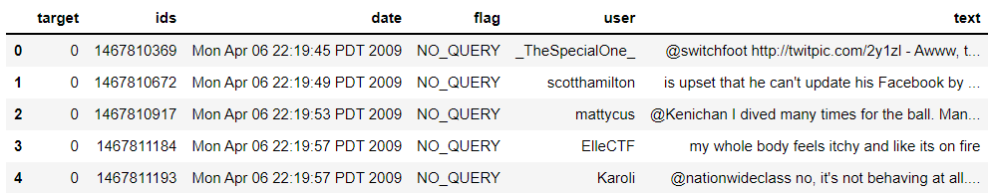

The data mining is done through proper selection. In tweepy we can mention various parameters which helps us to select a particular tweet. These tweets make our model and help us to overcome the limitations and challenges in the present in the present model. Our new improvements and increase of accuracy for a particular domain and involvement of world knowledge is done through the data mining process itself.

